**Project Plan for A3 (Applied AI & Analytics) Training and Consultancy**

Page Layout Key Components

# Submission:

* Name: Ethan Tan Wee En
* Admin no.: p2012085
* Class: DAAA/FT/1A/03
* School: School of Computing
* Date: 03/07/2020

# Objectives:

* Improve A3 Training and Consultancy's online presence
* Make information about the company's programmes and contact details available online
* Enable prospective customers to view and review the organisation's courses online
* Enable prospective customers to learn, understand more about A.I. and employ it usefully
* Allow prospective customers to register for company-organised workshops, courses and to book consultations with the company's specialised A.I. or Analytics Instructors

# Persona (prospective customers/end-users):

* 25+
* Literate in English
* Have good Mathematics foundation
* Have some knowledge or application of A.I.
* Likely require A.I. application in their line of work
* Have some experience navigating through websites on their own

# Sitemap

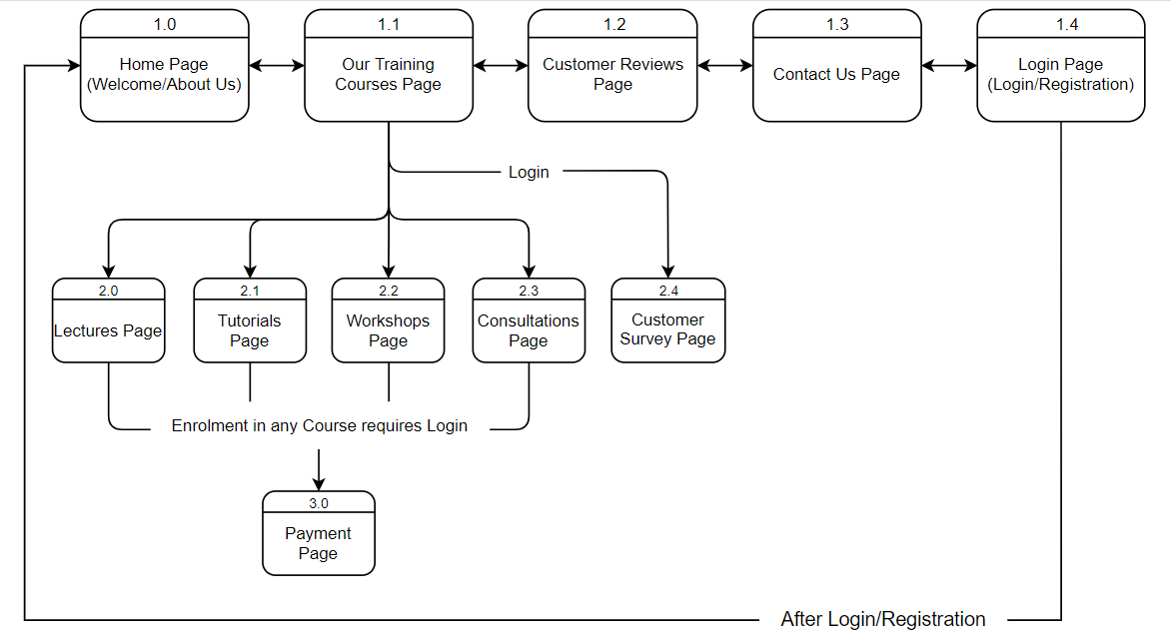

# Generic styles

# Unless otherwise stated, these would be the **general** theme for the webpages:

* Colour Scheme: - Greenish-blue

- Grey

* Typography: - Mostly Serif fonts

- Some use of Monospace fonts

# Page Layouts

1.0 Home Page Layout

1.0 Home Page (About Us/Welcome Page)

Home Page

Company Logo

1v

2v

Navigation Bar

8

Organisational Details

3v

Welcome

7v

Director’s Quotes

Welcome Image/Photo

4v

5

Company Objective and Welcome Message

6

Mission, Vision and Values

Annotations:

1. Quotes from the company's director

* Text is justified
* In the form of <q>/<blockquote>/<cite>
* Use of a Serif font

1. Organisation Details at Footer

* Comprises succinct details of the company's headquarters
* Contains my personal details (name, class, admin number, etc.)

1. Placeholder for the Website's Logo

* Image and/or background colours

1. Placeholder for the Website's Navigation Bar

* Use of Bootstrap's responsive Navbar

1. Main Portion of Welcome Content
2. Image of Staff/Company Building

* Image

1. Company's Objective and Welcome Message

* Why the company made this website
* General welcome message

1. Organisation's Mission, Vision and Values

* May use Bootstrap Cards
* 3 Segments

1.1 Our Training Courses Page Layout

1.1 Our Training Courses Page (links to Lectures, Tutorials, Workshops, Consultations Pages)

Our Training Courses Page

1v

Company Logo

2v

Navigation Bar

Our Training Courses

3v

Side Navigation Bar

Overview of the Courses

<Our Online Courses> <Our On-Site Courses>

5v

4v

*Our Workshops*

Overview…

Instructors…

Upcoming Workshops…

*Our Lectures*

Overview…

Lecturers…

Available Topics…

6v

Give us your Feedback!

*Our Tutorials*

Overview…

Tutors…

Available Topics…

*Consultations*

Overview…

Contacts of Instructors…

7

Organisational Details

Annotations:

1. Placeholder for the Website's Logo (same as 1.0)
2. Placeholder for the Website's Navigation Bar (same as 1.0)
3. Main Portion of Content
4. Overview of Training Courses Offered by the Company

* May use Bootstrap Cards
* Links to the Lectures, Tutorials, Workshops and Consultations Pages

1. Placeholder for the Page's Local Navigation Bar

* Likely to be hosted within an <aside> element
* With links to sections on the current page
* Organised vertically

1. Link to Customer Survey Page

* Available and visible to members only (after login)

1. Organisational Details at Footer (same as 1.0)

1.2 Customer Reviews Page Layout

1.2 Customer Reviews Page (past reviews from members)

Customer Reviews Page

1v

Company Logo

3v

Navigation Bar

2v

Customer Reviews

6v

Side Navigation Bar

4v

Overall Ratings

Reviews

5

7

Organisational Details

Annotations:

1. Placeholder for the Website's Logo (same as 1.0)
2. Placeholder for the Website's Navigation Bar (same as 1.0)
3. Main Portion of Content
4. Overall Ratings from Past Customer Surveys

* Use of <table>, <list> or <description List> (d-list)

1. Customer Reviews

* Contains feedback in text form
* Likely separated into the 4 categories: Tutorials, Lectures, Workshops, Consultations
* Bootstrap Carousels employed
* May use Bootstrap Jumbotrons

1. Placeholder for the Page's Local Navigation Bar (same as 1.1)
2. Organisational Details at Footer (same as 1.0)

1.3 Contact Us Page Layout

1.3 Contact Us Page (organisation's contact details and locations)

Contact Us Page

1v

Company Logo

3v

Navigation Bar

2v

Contact Us

5v

Side Navigation Bar

4

Locations and Contact Details

Organisational Details

6

Annotations:

1. Placeholder for the Website's Logo (same as 1.0)
2. Placeholder for the Website's Navigation Bar (same as 1.0)
3. Main Portion of Content
4. Locations and Contact Details

* of the Company's HQ, major and minor branches
* of the Company's Senior Staff

1. Placeholder for the Page's Local Navigation Bar (same as 1.1)
2. Organisational Details at Footer (same as 1.0)

1.4 Login Page Layout

1.4 Login Page (for existing members to sign in; for new members to sign up)

1.0

Login Page

Company Logo

1v

2

Navigation Bar

For new members:

I want to receive news and updates

I agree to the Terms & Conditions

4

3v

For existing members:

Email Address

Password

Forgot password

Keep me logged in

John

First Name:

Last Name:

Email Address:

Confirm Email:

New Password:

Confirm Password:

Smith

Enter Email

Enter Your Email

Re-enter Your Email

Enter Password

Enter Password

Re-enter Password

Sign Up

Sign In

Terms and Conditions; Registration Details

5

Organisational Details

6

Annotations:

1. Placeholder for the Website's Logo (same as 1.0)
2. Placeholder for the Website's Navigation Bar (same as 1.0)
3. Login for Existing Members

* "Sign In" brings user back to Home (1.0) Page with extra permissions (course registrations, customer survey)

1. Registration for New Members

* "Sign Up" brings user back to Home (1.0) Page with extra permissions (course registrations, customer survey)
* "Sign Up" will be readonly until the 2nd checkbox ("I agree to the Ts & Cs") is checked

1. Display of Terms and Conditions

* Use of Serif font
* May use small-caps
* Consists of privacy policy, registration details (this list is not exhaustive)

1. Organisation Details at Footer (same as 1.0)

2.0/2.1 Lectures, Tutorials Pages Layout

2.0/2.1 Lectures, Tutorials Pages

1.0

Lectures/Tutorials Pages

1v

Company Logo

Navigation Bar

2v

Our Lectures/Tutorials

3

Lecture/Tutorial Course 1

Lecture/Tutorial Course 2

…

4

Overview: …

Topics Covered: …

Fees: …

Lecturer/Tutor: …

Overview: …

Topics Covered: …

Fees: …

Lecturer/Tutor: …

5

Enrolment Details

6

Organisational Details

Annotations:

1. Placeholder for the Website's Logo (same as 1.0)
2. Placeholder for the Website's Navigation Bar (same as 1.0)
3. Main Portion of Content
4. Lectures/Tutorials available/upcoming

* Organised as nested lists or <description lists>

1. Enrolment Details

* Instructions on how to enrol in each type of course
* Has link to Payment Page

1. Organisation Details at Footer (same as 1.0)

Notes:

* This page layout represents both the Lectures and Tutorials Pages as they share similar layouts

2.2 Workshops Page Layout

2.2 Workshops Page

1.0

Workshops Page

1v

Company Logo

Navigation Bar

2v

Our Workshops

3

Our Upcoming Workshops

|  |  |  |  |  |  |  |
| --- | --- | --- | --- | --- | --- | --- |
| Sun | Mon | Tue | Wed | Thu | Fri | Sat |
|  |  |  |  |  |  | 1 |
| 2 | 3 | 4 | 5 | 6 | 7 | 8 |
| 9 | 10 | 11 | 12 | 13 | 14 | 15 |
| 16 | 17 | 18 | 19 | 20 | 21 | 22 |
| 23 | 24 | 25 | 26 | 27 | 28 | 29 |
| 30 | 31 |  |  |  |  |  |

August 2020

4

5

Workshop 1

Details…

6

Enrolment Details

7

Organisational Details

Annotations:

1. Placeholder for the Website's Logo (same as 1.0)
2. Placeholder for the Website's Navigation Bar (same as 1.0)
3. Main Portion of Content
4. Upcoming Workshops

* Organised in a <table>
* Formatted as a calendar

1. Workshop Details

* Each upcoming workshop will be fitted into one Carousel item

1. Enrolment Details (same as 2.0)
2. Organisation Details at Footer (same as 1.0)

2.3 Consultations Page Layout

2.3 Consultations Page

1.0

Consultations Page

1v

Company Logo

Navigation Bar

2v

Consultations

3

4

Overview

Our Domains

Programming Fundamentals

*Instructor's Name*

*Instructor's Status*

*Instructor's Contact Details*

*Instructor 2's Name*

*Instructor 2's Status*

*Instructor 2's Contact Details*

5

A.I. Basics

…

Organisational Details

6

Annotations:

1. Placeholder for the Website's Logo (same as 1.0)
2. Placeholder for the Website's Navigation Bar (same as 1.0)
3. Main Portion of Content
4. Overview

* Reasons for having consultations
* How to book a consultation slot

(with the company's specialised instructors)

1. Contacts and Details of Instructors

* Displayed as <lists>/<description lists>
* Organised by domains (specialisation)

1. Organisation Details at Footer (same as 1.0)

2.4 Customer Survey Page Layout

2.4 Customer Survey Page (allow members to provide feedback and rate the services provided)

Customer Survey Page

Company Logo

1v

3v

Navigation Bar

2v

Customer Survey

Side Navigation Bar

8v

Request for feedback

4v

Customer Survey Form

5

6

Privacy Declaration Statements

7

Terms and Conditions

Organisational Details

9

Annotations:

1. Placeholder for the Website's Logo (same as 1.0)
2. Placeholder for the Website's Navigation Bar (same as 1.0)
3. Main Portion of Content
4. Purpose of Feedback

* Short <paragraph(s)>

1. Customer Survey

* Web <form>
* Has <required> fields
* Has <disabled> fields (these will be enabled after the user has logged in)

1. Statements Declaring the Company's Discreet Use of the User's Personal Information (may swap with 7)
2. Terms and Conditions (may swap with 6)

* Use of small-caps

1. Placeholder for the Page's Local Navigation Bar (same as 1.1)
2. Organisational Details at Footer (same as 1.0)

3.0 Payment Page Layout

3.0 Payment Page (consolidating payment for course enrolment)

Payment Page

1v

Company Logo

3v

Navigation Bar

2v

Payment

Back

4

5

Payment form

(Web form)

6

Terms & Conditions

Organisational Details

7

Annotations:

1. Placeholder for the Website's Logo (same as 1.0)
2. Placeholder for the Website's Navigation Bar (same as 1.0)
3. Main Portion of Content
4. Back Button

* Brings user to previous Page (cancels enrolment order)

1. Payment form

* Web form
* May display courses selected previously readonly fields

1. Terms & Conditions

* Use of small-caps

1. Organisational Details at Footer (same as 1.0)